**SYSTEM SOFTWARE AND OPERATING SYSTEM LABORATORY**

**(15CSL67)**

**1a. Write a LEX program to recognize valid arithmetic expression. Identifiers in the expression could be only integers and operators could be + and *. Count the identifiers & operators present and print them separately.**

%{

#include<stdio.h>

int v=0,op=0,id=0,flag=0;

%}

%%

[a-z A-Z]+[0-9 A-Z a-z]* {id++;printf("\n Identifier:");ECHO;}

[\+\-\*\/\=] {op++;printf("\n Operator:");ECHO;}

"(" {v++;}

")" {v--;}

";" {flag=1;}

.|\n {;}

%%

int main()

{

printf("enter the expression");

yylex();

if(((op+1)==id)&&(v==0)&&(flag==0))

{

printf("\n valid expression\n");

printf("Number of identifiers = %d\n",id);

printf("Number of operators = %d\n",op);

}

else

printf("\n Invalid expression\n");

}

int yywrap()

{

return 1;

}

**Execution Steps:**

Lex <lexfilename.l>

cc lex.yy.c –ll

. /a.out <temp.txt>

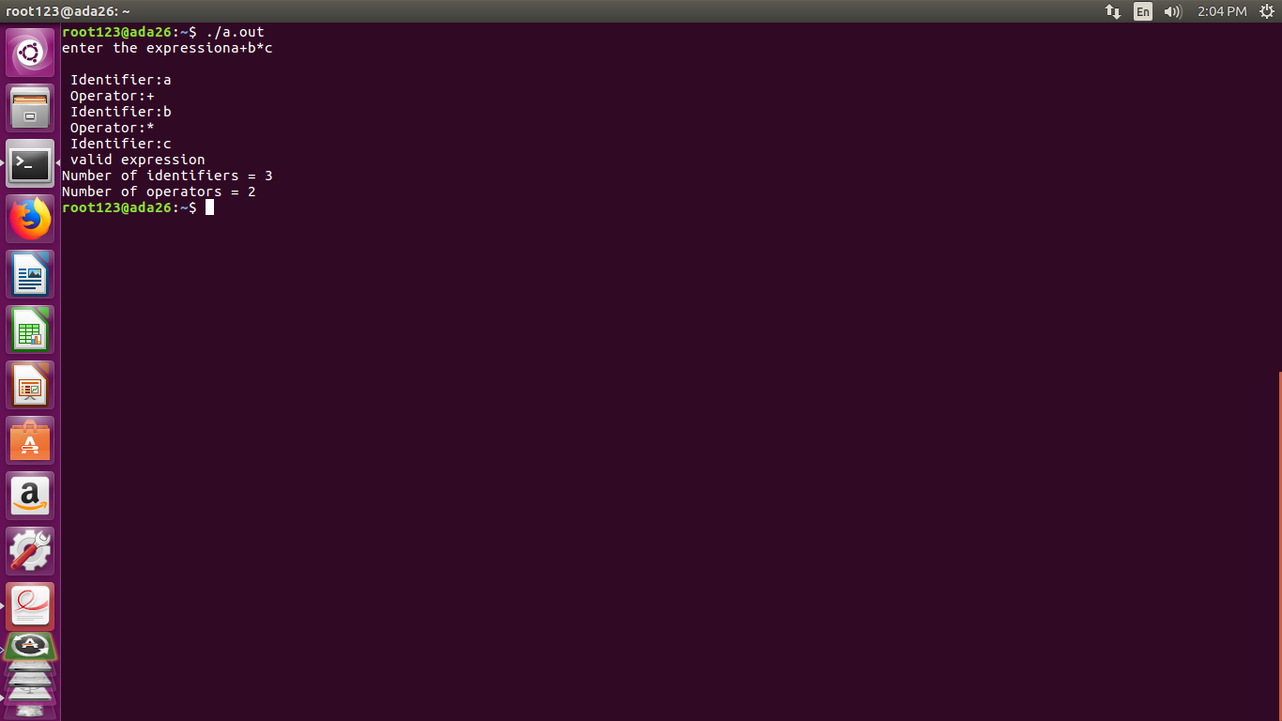

**b. Write YACC program to evaluate arithmetic expression involving operators:**

**+, -, * and /**

**Lex Part**

%{

#include "y.tab.h"

extern yylval;

%}

%%

[0-9]+ {yylval=atoi(yytext);return num;} **/* convert the string to number and send the value*/**

[\+\-\*\/] {return yytext[0];}

* {return yytext[0];}
* {return yytext[0];}

. {;}

\n {return 0;}

%%

**YACC Part**

%{

#include<stdio.h>

#include<stdlib.h>

%}

%token num

%left '+' '-'

%left '*' '/'

%%

input:exp {printf("%d\n",$$);exit(0);}

exp:exp'+'exp {$$=$1+$3;}

|exp'-'exp{$$=$1-$3;}

|exp'*'exp{$$=$1*$3;}

|exp'/'exp { if($3==0){printf("Divide by Zero\n");exit(0);} else

$$=$1/$3;}

|'('exp')'{$$=$2;}

|num{$$=$1;};

%%

int yyerror()

{

printf("error");

exit(0);

}

int main()

{

printf("Enter an expression:\n");

yyparse();

}

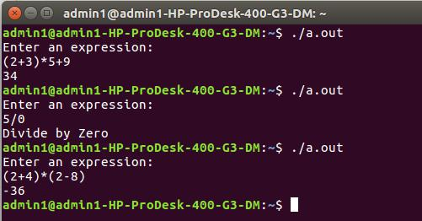

1. **Develop, Implement and execute a program using YACC tool to recognize all strings ending with *b* preceded by *n a’s* using the grammar *a n b* (note: input *n* value).**

**Lex Part**

%{

#include "y.tab.h"

%}

%%

a {return A;}

b {return B;}

[\n] return '\n';

%%

**YACC Part**

%{

#include<stdio.h>

#include<stdlib.h>

%}

%token A B

%%

input:s'\n' {printf("Successful Grammar\n");exit(0);}

1. A s1 B| B s1: ; | A s1

%%

main()

{

printf("Enter A String\n"); yyparse();

}

int yyerror()

{

printf("Error \n");

exit(0);

}

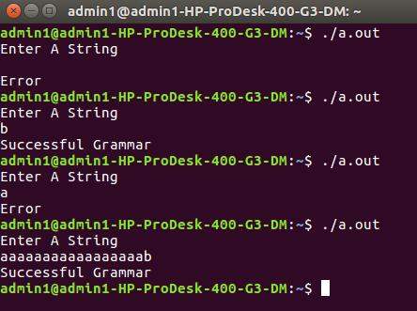

1. **Design, develop and implement YACC/C program to construct *Predictive / LL(1) Parsing Table* for the grammar rules*: A →aBa , B →bB | ε*. Use this table to parse the sentence*: abba$.***

#include <string.h>

#include <stdio.h>

#include <stdlib.h>

char STACK[20]="\0";

int TOP=-1,flag=0;

int B_ptr = 0;

char BUFFER[20],G_prod[20];

char table [3][3][10] = {

"NT", "a","b",

"A", "aBa","Error",

"B", "Îµ","bB",

};

char pop()

{

char ch;

ch = STACK[TOP--];

return ch;

}

void push(char ch)

{

STACK[++TOP] = ch;

}

void stack_content()

{

if (TOP != -1)

{

int i = 0;

printf("\nstack content: ");

while(i <= TOP)

{

printf("%c",STACK[i++]);

}

printf("\n");

}

return;

}

int isterm(char c)

{

if (c >= 'a' && c <= 'z')

return 1;

else

return 0;

}

int Parser_table(char stack_top,char buf_value,int flag)

{

int r,c;

switch(stack_top)

{

case 'A' : r = 1; break;

case 'B' : if(flag<=5) r = 2; else r = 3;

}

switch(buf_value)

{

case 'a' : c = 1; break;

case 'b' : c = 2;

}

if (strcmp(table[r][c],"error") == 0)

return 0;

if (strcmp(table[r][c],"Îµ") != 0)

{

strcpy(G_prod,table[r][c]);

}

return 1;

}

int main()

{

int i,j,stln;

printf("LL(1) PARSER TABLE \n");

for(i=0;i<3;i++)

{

for(j=0;j<3;j++)

{

printf("%s\t",table[i][j]);

}

printf("\n");

}

printf("\n");

printf("ENTER THE STRING into the Buffer and also give a ';' as the terminator: ");

scanf("%s",BUFFER);

printf("\n THE STRING in the Buffer is %s",BUFFER);

if(BUFFER[strlen(BUFFER)-1] != ';')

{

printf("END OF STRING MARKER SHOULD BE ';'");

exit(0);

}

push('$');

push('A');

while(STACK[TOP] != '$') // Stack is not Empty

{

flag++;

if (STACK[TOP] == BUFFER[B_ptr]) // X is a

{

printf("\n1.The poped item is - %c,",pop());

B_ptr++;

printf("\t buffer cont - %.*s",strlen(BUFFER),BUFFER+B_ptr);

}

else if(isterm(STACK[TOP])) // is X is terminal

{

printf("\n2. $ %c",STACK[TOP]);

printf("\t Error in Parsing \n");

}

else

if (!Parser_table(STACK[TOP],BUFFER[B_ptr],flag))

printf("3. Error Entry in Parse Table ");

else

if (Parser_table(STACK[TOP],BUFFER[B_ptr],flag))

{

if (flag < 6 && strcmp(G_prod,"Îµ") != 0)

{

printf("\n4.1 flag = %d, prod id- %s*\t",flag,G_prod);

pop();

stln = strlen(G_prod);

for(i=stln-1;i>=0;i--)

push(G_prod[i]);

stack_content();

}

else

{

stack_content();

printf("\n4.2 flag = %d *reduce by %s*",flag,"B->Îµ");

pop();

printf("\t buffer content is %c",BUFFER[B_ptr]);

}

}

}

if (STACK[TOP] == '$' && BUFFER[B_ptr] == ';')

printf("\n** The string is accepted **");

else

printf("\n** The string is not accepted **");

}

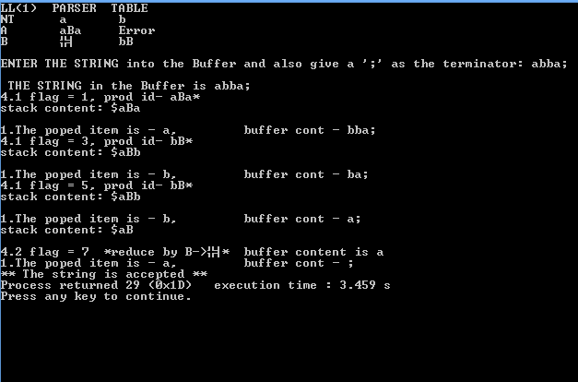

1. Design, develop and implement YACC/C program to demonstrate ***Shift Reduce Parsing*** technique for the grammar rules: ***E →E+T | T, T →T*F | F, F → (E) | id*** and parse the sentence***: id + id * id***.

#include<stdio.h>

#include<conio.h>

#include<string.h>

int k=0,z=0,i=0,j=0,c=0;

char a[16],ac[20],stk[15],act[10];

void check();

void main()

{

puts("GRAMMAR is E->E+E \n E->E*E \n E->(E) \n E->id");

puts("enter input string ");

gets(a);

c=strlen(a);

strcpy(act,"SHIFT->");

puts("stack \t input \t action");

for(k=0,i=0; j<c; k++,i++,j++)

{

if(a[j]=='i' && a[j+1]=='d')

{

stk[i]=a[j];

stk[i+1]=a[j+1];

stk[i+2]='\0';

a[j]=' ';

a[j+1]=' ';

printf("\n$%s\t%s$\t%sid",stk,a,act);

check();

}

else

{

stk[i]=a[j];

stk[i+1]='\0';

a[j]=' ';

printf("\n$%s\t%s$\t%ssymbols",stk,a,act);

check();

}

}

getch();

}

void check()

{

strcpy(ac,"REDUCE TO E");

for(z=0; z<c; z++)

if(stk[z]=='i' && stk[z+1]=='d')

{

stk[z]='E';

stk[z+1]='\0';

printf("\n$%s\t%s$\t%s",stk,a,ac);

j++;

}

for(z=0; z<c; z++)

if(stk[z]=='E' && stk[z+1]=='+' && stk[z+2]=='E')

{

stk[z]='E';

stk[z+1]='\0';

stk[z+2]='\0';

printf("\n$%s\t%s$\t%s",stk,a,ac);

i=i-2;

}

for(z=0; z<c; z++)

if(stk[z]=='E' && stk[z+1]=='*' && stk[z+2]=='E')

{

stk[z]='E';

stk[z+1]='\0';

stk[z+1]='\0';

printf("\n$%s\t%s$\t%s",stk,a,ac);

i=i-2;

}

for(z=0; z<c; z++)

if(stk[z]=='(' && stk[z+1]=='E' && stk[z+2]==')')

{

stk[z]='E';

stk[z+1]='\0';

stk[z+1]='\0';

printf("\n$%s\t%s$\t%s",stk,a,ac);

i=i-2;

}

}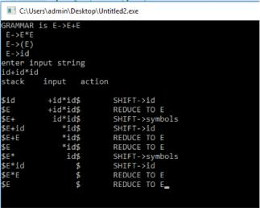

1. Design, develop and implement a C/Java program to generate the machine code using ***Triples*** for the statement ***A = -B * (C +D)*** whose intermediate code in three-address form:

***T1 = -B***

***T2 = C + D***

***T3 = T1 * T2***

***A = T3***

#include<stdio.h>

#include<stdlib.h>

#include<ctype.h>

#include<string.h>

char tset[4][3][3]= { {"-","B","?"}, {"+","C","D"}, {"*","0","1"}, {"=","A","2"} };

int main()

{

int row,col;

for(row=0;row<4;row++)

{

col=2;

if (tset[row][col][0]=='?')

{

printf("\nLD R0,%s%s",tset[row][0],tset[row][1]);

}

else

{

if(tset[row][0][0]=='+')

{

printf("\nLD R1,%s",tset[row][1]);

printf("\nLD R2,%s",tset[row][2]);

printf("\nADD R1,R1,R2");

}

else

{

if(tset[row][0][0]=='*')

{

printf("\nMUL R1,R1,R0");

}

else

{

printf("\nST %s,R1",tset[row][1]);

}

}

}

}

printf("\n"); return 0;

}

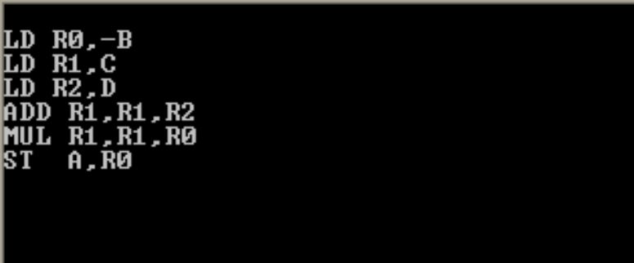

1. **a) Write a LEX program to eliminate *comment lines* in a *C* program and copy the resulting program into a separate file.**

%{

#include<stdio.h>

int c_count=0;

%}

%%

"/*"[^*/]*"*/" {c_count++;}

"//".* {c_count++;}

%%

int main( int argc, char **argv)

{

FILE *f1,*f2;

if(argc>1)

{

f1=fopen(argv[1],"r"); **/*open first file for reading*/**

if(!f1) **/*not able to open file*/**

{

printf("file error \n");

exit(1);

}

yyin=f1;

f2=fopen(argv[2],"w"); **/*open second file for writing*/**

if(!f2) **/*not able to open file*/**

{

printf("Error");

exit(1);

}

yyout=f2;

yylex();

printf("Number of Comment Lines: %d\n",c_count);

}

return 0;

}

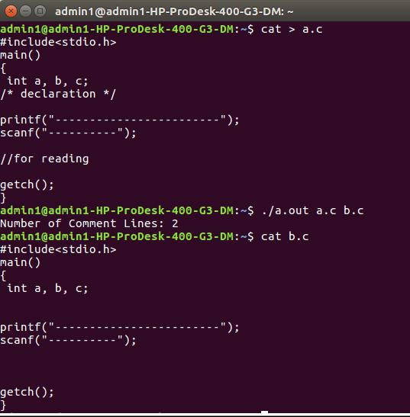

1. **Write YACC program to recognize valid *identifier, operators* and *keywords* in the given text (C program) file.**

**Lex File**

%{

#include <stdio.h>

#include "y.tab.h"

extern yylval;

%}

%%

[ \t] ;

[+|-|*|/|=|<|>] {printf("operator is %s\n",yytext);return OP;}

[0-9]+ {yylval = atoi(yytext); printf("numbers is %d\n",yylval); return DIGIT;}

int|char|bool|float|void|for|do|while|if|else|return|void {printf("keyword is

%s\n",yytext);return KEY;}

[a-zA-Z0-9]+ {printf("identifier is %s\n",yytext);return ID;}

. ;

%%

**Yacc File**

%{

#include <stdio.h>

#include <stdlib.h>

int id=0, dig=0, key=0, op=0;

%}

%token DIGIT ID KEY OP

%%

input:

DIGIT input { dig++; }

| ID input { id++; }

| KEY input { key++; }

| OP input {op++;}

| DIGIT { dig++; }

| ID { id++; }

| KEY { key++; }

| OP { op++;}

;

%%

#include <stdio.h>

extern int yylex();

extern int yyparse();

extern FILE *yyin;

main()

{

FILE *myfile = fopen("sam_input.c", "r");

if (!myfile) {

printf("I can't open sam_input.c!");

return -1;

}

yyin = myfile;

do {

yyparse();

} while (!feof(yyin));

printf("numbers = %d\nKeywords = %d\nIdentifiers = %d\noperators = %d\n",

dig, key,id, op);

}

void yyerror() {

printf("EEK, parse error! Message: ");

exit(-1);



}

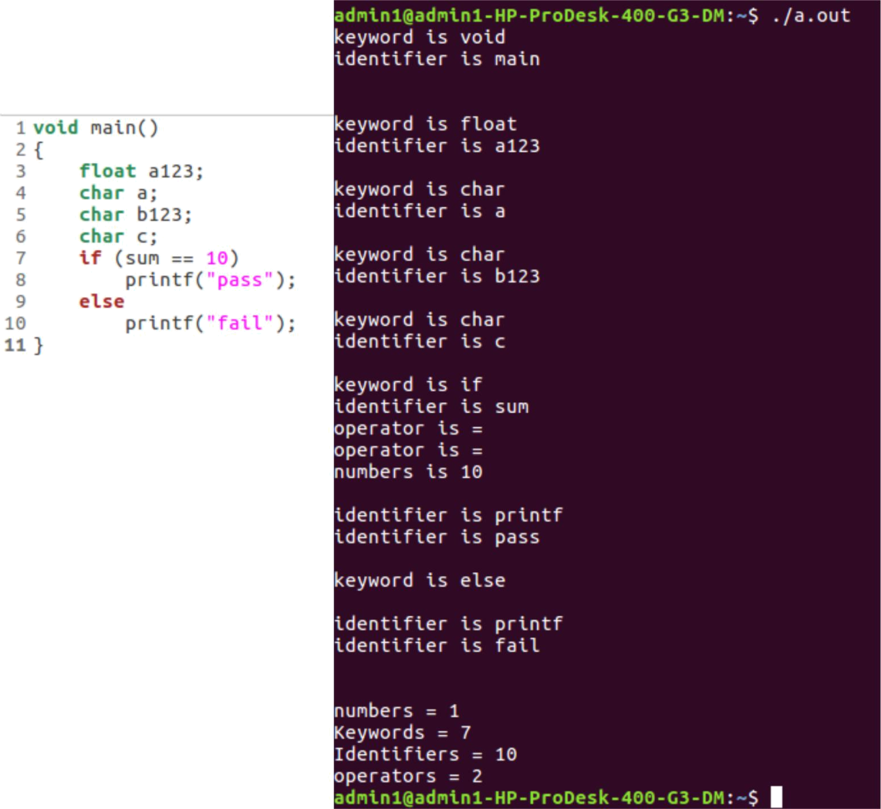

1. Design, develop and implement a C/C++/Java program to simulate the working of ***Shortest remaining*** ***time*** and ***Round Robin (RR)*** scheduling algorithms. Experiment with different quantum sizes for RR

algorithm.

#include<stdio.h>

#include<stdlib.h>

int arrival[10];

int burst[10];

int rem[10];

int wait[10];

int finish[10];

int turnaround[10];

int flag[10];

void roundrobin(int,int,int[],int[]);

void srtf(int);

int main()

{

int n,tq,choice;

int bt[10],st[10],i,j;

for(;;)

{

printf("enter the choice\n1. round robin\n 2.srt 3.Exit\n");

scanf("%d",&choice);

switch(choice)

{

case 1:

printf("enter no. of process:\n");

scanf("%d",&n);

printf("enter brust time\n");

for(i=0;i<n;i++)

{

scanf("%d",&bt[i]);

st[i]=bt[i];

}

printf("enter time quantum");

scanf("%d",&tq);

roundrobin(n,tq,st,bt);

break;

case 2:

printf("enter no. of process:\n");

scanf("%d",&n);

srtf(n);

break;

case 3:return 0;

}

}

}

void roundrobin(int n,int tq,int st[],int bt[])

{

int time=0;

int tat[10],wt[10],i,count=0,swt=0,stat=0,temp1,sq=0;

while(1)

{

for(i=0,count=0;i<n;i++)

{

temp1=tq;

if(st[i]==0)

{

count++;

continue;

}

if(st[i]>tq)

st[i]=st[i]-tq;

else

if(st[i]>=0)

{

temp1=st[i];

st[i]=0;

}

sq=sq+temp1;

tat[i]=sq;

}

if(n==count)

break;

}

for(i=0;i<n;i++)

{

wt[i]=tat[i]-bt[i];

swt=swt+wt[i];

stat=stat+tat[i];

}

printf("process_no burst time wait time turnaround time\n");

for(i=0;i<n;i++)

printf("%d\t\t%d\t\t%d\t\t%d\n",i+1,bt[i],wt[i],tat[i]);

printf("average waiting time is %f\n average turnaround time is %f\n",(float)swt/n,(float)stat/n);

}

void srtf(int n)

{

int stat=0,swt=0,time=0,count=0,i,j,min=999;

for(i=1;i<=n;i++)

{

printf("arrival of p%d:",i);

scanf("%d",&arrival[i]);

printf("burst of p%d:",i);

scanf("%d",&burst[i]);

rem[i]=burst[i];

flag[i]=0;

}

while(1)

{

for(i=1,min=999;i<=n;i++)

if(arrival[i]<=time&&flag[i]==0)

if(rem[i]<min)

{

min=rem[i];

j=i;

}

time++;

rem[j]-=1;

if(rem[j]==0)

{

finish[j]=time;

flag[j]=1;

count++;

}

if(count==n)

break;

}

for(i=1;i<=n;i++)

{

turnaround[i]=finish[i]-arrival[i];

wait[i]=turnaround[i]-burst[i];

stat+=turnaround[i];

swt+=wait[i];

}

printf("the process table:\n\t process no.\t|finish\t|wait\t|turnaround\t\n");

for(i=1;i<=n;i++)

printf("\t%d \t%d \t%d \t%d \t%d \t%d\n",i,arrival[i],burst[i],finish[i],wait[i],turnaround[i]);

printf("averagewaittime: %f\t avgturnaroundtime: %f\n",(float)swt/n,(float)stat/n);

return;

}

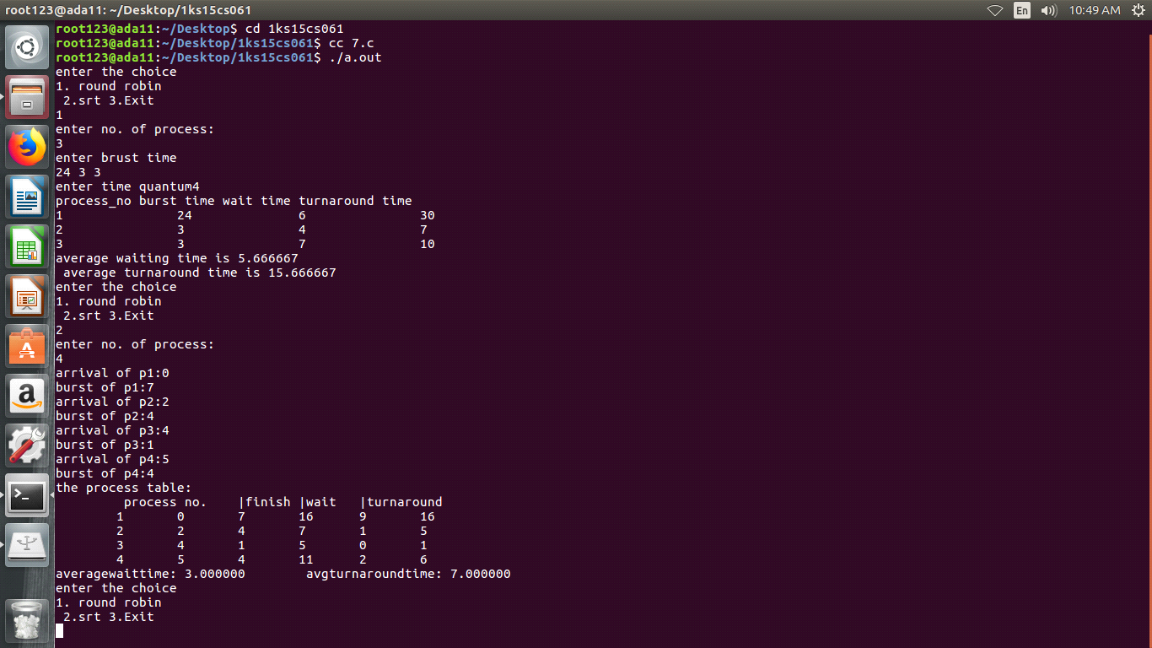

1. Design, develop and implement a C/C++/Java program to implement ***Banker’s algorithm***. Assume suitable input required to demonstrate the results.

#include <stdio.h>

#include <stdlib.h>

int main()

{

int Max[10][10], need[10][10], alloc[10][10], avail[10], completed[10], safeSequence[10];

int p, r, i, j, process, count;

count = 0;

printf("Enter the no of processes : ");

scanf("%d", &p);

for(i = 0; i< p; i++)

completed[i] = 0;

printf("\n\nEnter the no of resources : ");

scanf("%d", &r);

printf("\n\nEnter the Max Matrix for each process : ");

for(i = 0; i < p; i++)

{

printf("\nFor process %d : ", i + 1);

for(j = 0; j < r; j++)

scanf("%d", &Max[i][j]);

}

printf("\n\nEnter the allocation for each process : ");

for(i = 0; i < p; i++)

{

printf("\nFor process %d : ",i + 1);

for(j = 0; j < r; j++)

scanf("%d", &alloc[i][j]);

}

printf("\n\nEnter the Available Resources : );

for(i = 0; i < r; i++)

scanf("%d", &avail[i]);

for(i = 0; i < p; i++)

for(j = 0; j < r; j++)

need[i][j] = Max[i][j] - alloc[i][j];

do

{

printf("\n Max matrix:\tAllocation matrix:\n");

for(i = 0; i < p; i++)

{

for( j = 0; j < r; j++)

printf("%d ", Max[i][j]);

printf("\t\t");

for( j = 0; j < r; j++)

printf("%d ", alloc[i][j]);

printf("\n");

}

process = -1;

for(i = 0; i < p; i++)

{

if(completed[i] == 0)//if not completed

{

process = i ;

for(j = 0; j < r; j++)

{

if(avail[j] < need[i][j])

{

process = -1;

break;

}

}

}

if(process != -1)

break;

}

if(process != -1)

{

printf("\nProcess %d runs to completion!", process + 1); safeSequence[count] = process + 1; count++;

for(j = 0; j < r; j++)

{

avail[j] += alloc[process][j];

alloc[process][j] = 0;

Max[process][j] = 0;

completed[process] = 1;

}

}

}

while(count != p && process != -1);

if(count == p)

{

printf("\nThe system is in a safe state!!\n");

printf("Safe Sequence : < ");

for( i = 0; i < p; i++)

printf("%d ", safeSequence[i]);

printf(">\n");

}

else

printf("\nThe system is in an unsafe state!!");

}

**Output:**

Enter the no of processes : 5

Enter the no of resources : 3

Enter the Max Matrix for each process :

For process 1 : 7

5

3

For process 2 : 3

2

2

For process 3 : 7

0

2

For process 4 : 2

2

2

For process 5 : 4

3

3

Enter the allocation for each process :

For process 1 : 0

1

0

For process 2 : 2

0

0

For process 3 : 3

0

2

For process 4 : 2

1

1

For process 5 : 0

0

2

Enter the Available Resources : 3

|  |  |  |  |
| --- | --- | --- | --- |
| 3 |  |  | |
| 2 |  |  | |
| Max matrix: | | Allocation matrix: | |
| 7 5 3 | 0 | 1 0 | |
| 3 2 2 | 2 | 0 0 | |
| 7 0 2 | 3 | 0 2 | |
| 2 2 2 | 2 | 1 1 | |
| 4 3 3 | 0 | 0 2 | |
| Process 2 runs to completion! | | | |
| Max matrix: | | Allocation matrix: | |
| 7 5 3 | 0 | 1 0 | |
| 0 0 0 | 0 | 0 0 | |
| 7 0 2 | 3 | 0 2 | |
| 2 2 2 | 2 | 1 1 | |
| 4 3 3 | 0 0 2 | | | |
| Process 3 runs to completion! | | | | |
| Max matrix: | | | Allocation matrix: | |
| 7 5 3 | 0 1 0 | | | |
| 0 0 0 | 0 0 0 | | | |
| 0 0 0 | 0 0 0 | | | |
| 2 2 2 | 2 1 1 | | | |
| 4 3 3 | 0 0 2 | | | |
| Process 4 runs to completion! | | | | |
| Max matrix: | | | Allocation matrix: | |
| 7 5 3 | 0 1 0 | | | |
| 0 0 0 | 0 0 0 | | | |
| 0 0 0 | 0 0 0 | | | |
| 0 0 0 | 0 0 0 | | | |
| 4 3 3 | 0 0 2 | | | |
| Process 1 runs to completion! | | | | |
| Max matrix: | | | Allocation matrix: | |
| 0 0 0 | 0 0 0 | | | |
| 0 0 0 | 0 0 0 | | | |
| 0 0 0 | 0 0 0 | | | |
| 0 0 0 | 0 0 0 | | | |
| 4 3 3 | 0 0 2 | | | |

Process 5 runs to completion!

The system is in a safe state!!

Safe Sequence: < 2 3 4 1 5 >

1. Design, develop and implement a C/C++/Java program to implement ***page replacement algorithms LRU*** and ***FIFO***. Assume suitable input required to demonstrate the results.

#include<stdio.h>

#include<stdlib.h>

void FIFO()

{

char s[200];

char F[200];

int l,f,i,j=0,k,flag=0,cnt=0;

printf("\nEnter the number of frames : ");

scanf("%d",&f);

printf("\nEnter the length of the string: ");

scanf("%d",&l);

printf("\nEnter the string: ");

scanf("%s", s);

for(i=0;i<f;i++)

F[i]=' ';

printf("\n\tPAGE\t\tFRAMES\t\t\tFAULTS");

for(i=0;i<l;i++)

{

for(k=0;k<f;k++)

if(F[k]==s[i])

flag=1;

if(flag==0)

{

printf("\n\t%c\t",s[i]);

F[j]=s[i];

j++;

for(k=0;k<f;k++)

printf("\t%c",F[k]);

printf("\tPage-fault%d",cnt);

cnt++;

}

else

{

flag=0;

printf("\n\t%c\t",s[i]);

for(k=0;k<f;k++)

printf("\t%c",F[k]);

printf("\tNo page-fault");

}

if(j==f)

j=0;

}

}

int findLRU(int time[], int n)

{

int i, minimum = time[0], pos = 0;

for(i = 1; i < n; ++i)

{

if(time[i] < minimum)

{

minimum = time[i];

pos = i;

}

}

return pos;

}

int lru()

{

int no_of_frames, no_of_pages, frames[10], counter = 0;

int time[10], flag1, flag2, i, j, pos, faults = 0, page;

char s[200];

printf("\nEnter number of frames: ");

scanf("%d", &no_of_frames);

printf("\nEnter number of pages: ");

scanf("%d", &no_of_pages);

printf("\nEnter reference string: ");

scanf("%s", s);

for(i = 0; i < no_of_frames; ++i)

frames[i] = -1;

for(i = 0; i < no_of_pages; ++i)

{

flag1 = flag2 = 0;

page = s[i] - '0';

for(j = 0; j < no_of_frames; ++j)

{

if(frames[j] == page)

{

counter++;

time[j] = counter;

flag1 = flag2 = 1;

break;

}

}

if(flag1 == 0)

{

for(j = 0; j < no_of_frames; ++j)

{

if(frames[j] == -1)

{

counter++;

faults++;

frames[j] = page;

time[j] = counter;

flag2 = 1;

break;

}

}

}

if(flag2 == 0)

{

pos = findLRU(time, no_of_frames);

counter++;

faults++;

frames[pos] = page;

time[pos] = counter;

}

printf("\n");

for(j = 0; j < no_of_frames; ++j)

printf("%d\t", frames[j]);

}

printf("\n\nTotal Page Faults = %d", faults);

return 0;

}

int main()

{

int ch,YN=1,i,l,f;

char F[10],s[25];

do

{

printf("\nOptions : ");

printf("\n\n1:FIFO\n2:LRU \n3:EXIT");

printf("\n\nEnter your choice: ");

scanf("%d",&ch);

switch(ch)

{

case 1: FIFO();

break;

case 2: lru();

break;

default:

exit(0);

}

printf("\n\nPress 1 to continue.. 0 to exit ");

scanf("%d",&YN);

}while(YN==1);

return(0);

}

